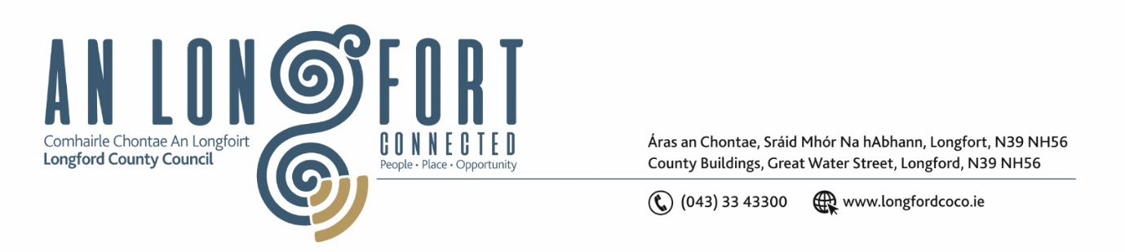

***LONGFORD MUNICIPAL DISTRICT***

***Please note meeting will be held in Council Chamber and via Microsoft Teams***

**16th September 2021.**

**To: Each Member of Longford Municipal District.**

**Dear Member,**

You are requested to attend the Meeting of Longford Municipal District to be held

**in Council Chamber, Aras an Chontae and via Microsoft Teams** on **Wednesday 22nd September 2021 at 3.30pm** to transact business, as set out on the Agenda hereunder.

**Yours sincerely**,

Ann Marie Mc Keon

_______________

**Ann Marie Mc Keon**

**Meetings Administrator.**

**AGENDA**

Prayer before meeting.

**1.** Confirmation of Minutes of

1. Longford Municipal District Meeting held on Wednesday 28th July 2021 – copy enclosed.
2. Longford Municipal District Committee Meeting held on Wednesday 28th July 2021- copy enclosed.

**2.** Matters arising from Minutes.

**3.** Declaration of Interest by Members.

**4.** Management Report - enclosed.

**5**. Proposed Projects/Expression of interests - enclosed.

**6. Notices of Motions, submitted by Councillors, as listed hereunder –**

**Councillor Uruemu Adejinmi**

I call on Longford County Council to progress with the acquisition/compulsory purchase order of properties within the Camlin Masterplan to effectively deliver the Urban Renewal Development funding.

**Councillor Seamus Butler**

‘That due to increased volumes and intensity of rainfall due to climate change, it is now critical that the surface and storm water systems are fit for purpose, especially as we approach the Autumn leaf and winter seasons. With this in mind I am calling for all the road gullies, shores and pipelines to be inspected, cleaned and fully functional to minimise the risk of spot flooding and damage to homes and commercial properties.’

**Councillor John Browne**

I call on Longford County Council to write to Iarnod Road Éireann requesting that the company, erect higher steel fencing, at the level crossing at Knockahaw, Ardnacassa off Dublin Road, Longford and at Ardeevan, Ardnacassa Longford in order to prevent drug dealing activities, anti-social behaviour and people crossing over and back the rail line.”

**Councillor Martin Monaghan**

After several consultations with some of the School of Motoring providers, I would like to bring to the attention the area of road markings - some are barely visible and some completely missing, these markings are an essential part of the driving test grading. I feel it is imperative that these are brought up to proper standards for all road users.

**7. Correspondence**

Correspondence dated 14th September 2021 - Received from Johny Murtagh Re - The Government & Science Foundation Ireland Creating Our Future Campaign - Longford